Since the dawn of human civilization, education had always been one of the hottest topic among people. There has been a heated debate in recent years of whether the ultimate goal of education is self-education or not. Some say the ultimate goal of education is to educate people themselves, ~~while others oppose it by claiming that self-learning is not the final goal of education.~~ As far as I am concerned, I agree with the former one. My reasons are as follows.

To begin with, since people are accepting and utilizing technologies at every part of their life, teaching themselves how to use new equipment is a final goal of education. People can not stay inside an environment where there are always people teaching them new knowledge. People have to jump out of their comfort zone someday, or they will not be able to catch up the society. Take Bill Gates as an example, as the Industry 5.0 era is yet to come, being one of the leaders of the Industry 4.0 era, Bill Gates learned by himself about the new AI technologies, such as Chat GPT, and help developed the new Bing AI. Because he received well education in Harvard University, he learned how to educate himself about new technologies, so that he is able to catch up with the new trend of society.



（1）例子很好，因果关系再强化下（2）topic sentence 再精准下。 People who master the skill of self.。。。. adapt to the fast-paced society.

It is ...... that contributes to

Secondly, providing people the ability to educate themselves with knowledge is just one of the ultimate aims of education, while teaching people how to teach themselves to see things from a different perspective and to widen up their breadth is also a goal of education. Looking back to the past hundreds of years, many discriminations and inequalities have been prohibited, such as accepting females to work, stopping black and Asian hate, etc. The power of society advancement is people teaching themselves new perspectives using advanced perspectives. Without learning by themselves, hardly can people solve such massive an amount of problems and inequalities in such a short time. A great number of

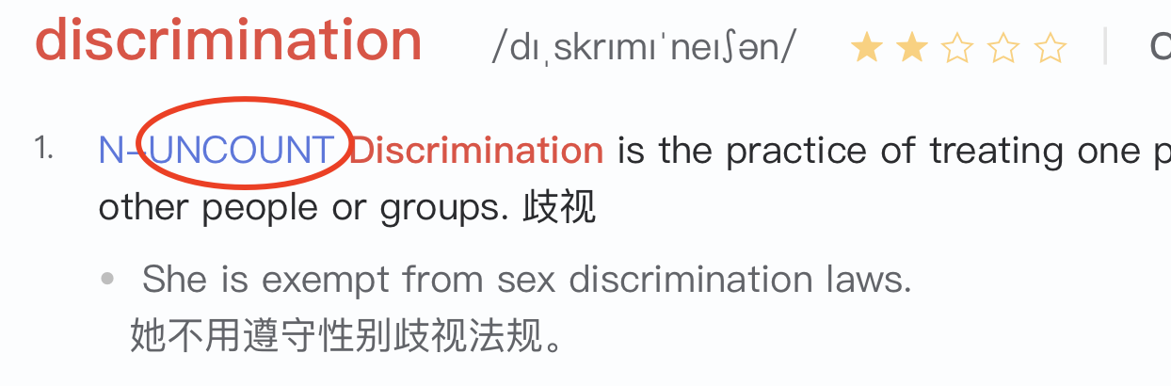

Admittedly, not all of the goals of education are to increase people’s self-learning. Education is also made for simply spreading knowledge to people who are in need. However, solving academic questions merely is only too small a portion that can be counted as the goal of education. Most of the main goals is to educate people to find out new problems, find the solution of the problem, and finally fulfill self-learning.

From all of the above, it is safe to draw the conclusion that the ultimate goal of education if to educate people themselves, as people can not learn new knowledge from other people, and the aim of education also contains broadening one’s eyesight and breadth.

强调句

虚拟句

Had done, would have done.

Be conducive to (介词)

It is never too old to learn.

Study is a life-long journey.

quality-oriented education (除了老师教，自学很重要： resources online: coursera)